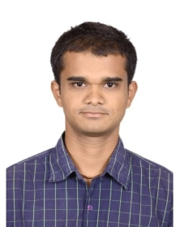
CURRICULUM VITAE

HARSIDDH PANCHAL

Email ():-harsiddhpanchal14694@gmail.com

Contact ():- 7359459319

OBJECTIVE:

A career, that provides opportunities for personal and professional development as well as to contribute to the effectiveness of organization in order to take the company to the top position wherever I work.

WORK AT FOLLOWING COMPANY

Training at WINDSOR PVT. LIMITED, AHEMEDABAD
Duration: for 10 days

ACADEMIC PROFILE:

Qualification | Board | School | Year | Percentage
S.S.C (10th) | GSEB | The J.M .Desai High School,Thasra | 2009 | 84.29%
H.S.C | GSEB | The J.M .Desai High School,Thasra | 2011 | 84.29%
B.E (MECH) | GTU | Government Engg.  College, Godhra | 2015 | 7.78(CGPA)  7.6(CPI)

Technical Skill/ Software Knowledge:-
- Basic knowledge of AutoCAD
Area of Interest:-
- Manufacturing Process, machine design and Maintenance.

ACADEMIC PROJECT:
- Motor cycle operated fertilizer sprayer.

PERSONAL DETAILS:

Name : Harsiddh Bharatbhai Panchal
Father’s Name : Bharatbhai Kirtanbhai Panchal
Address : Maitry society, Near Jain Temple, Thasra-388250
Date of Birth : June 14, 1994
Gender : Male
Nationality : Indian
Marital Status : Unmarried
Languages Known : English, Hindi and Gujarati
Hobbies : Playing Outdoor games, Listening music, travelling

Declaration:

I hereby declare that the above-mentioned information is true to the best of my knowledge.

Yours sincerely,
HARSIDDH PANCHAL

